**ARYAMAN MISHRA**

**19BCE1027**

#include <stdio.h>

#include <graphics.h>

#include <math.h>

#include <stdlib.h>

#include <dos.h>

#include <conio.h>

#define ORG -50

# define f 0.3

# define projection_angle 45

void show_screen( );

void apply_x_shearing(int[5][3],constfloat,constfloat);

void multiply_matrices(constfloat[4],constfloat[4][4],float[4]);

void draw_pyramid(constint [5][3]);

void get_projected_point(int&,int&,int&);

void Line(constint,constint,constint,constint);

void show_screen( );

void apply_y_shearing(int[5][3],constfloat,constfloat);

void multiply_matrices(constfloat[4],constfloat[4][4],float[4]);

void trans();

#define ORG -50

double face1[5][2] = {

{ 250, 125 },

{ 350, 125 },

{ 350, 225 },

{ 250, 225 },

{ 250, 125 }

};

double face2[5][2] = {

{ 250+ORG, 125-ORG },

{ 350+ORG, 125-ORG },

{ 350+ORG, 225-ORG },

{ 250+ORG, 225-ORG },

{ 250+ORG, 125-ORG }

};

double angle = 5.0 * M_PI / 180;

double midx1, midy1, midx2, midy2;

void rotate (void)

{

int i;

for (i=0; i<5; i++)

{

double xnew, ynew;

xnew = midx1 + (face1[i][0] - midx1) * cos (angle) -

(face1[i][1] - midy1) * sin (angle);

ynew = midy1 + (face1[i][0] - midx1) * sin (angle) +

(face1[i][1] - midy1) * cos (angle);

face1[i][0] = xnew;

face1[i][1] = ynew;

xnew = midx2 + (face2[i][0] - midx2) * cos (angle) -

(face2[i][1] - midy2) * sin (angle);

ynew = midy2 + (face2[i][0] - midx2) * sin (angle) +

(face2[i][1] - midy2) * cos (angle);

face2[i][0] = xnew;

face2[i][1] = ynew;

}

cleardevice();

for (i=0; i<4; i++)

{

setcolor(7);

line (face1[i][0], face1[i][1], face1[i+1][0], face1[i+1][1]);

setcolor(8);

line (face2[i][0], face2[i][1], face2[i+1][0], face2[i+1][1]);

setcolor(9);

line (face1[i][0], face1[i][1], face2[i][0], face2[i][1]);

}

delay (125);

}

void apply_y_shearing(int edge_points[5][3],constfloat a,constfloat b)

{

for(int count=0;count<5;count++)

{

float matrix_a[4]={edge_points[count][0],edge_points[count][1],

edge_points[count][2],1};

float matrix_b[4][4]={

{ 1,0,0,0 } ,

{ a,1,b,0 } ,

{ 0,0,1,0 } ,

{ 0,0,0,1 }

};

float matrix_c[4]={0};

multiply_matrices(matrix_a,matrix_b,matrix_c);

edge_points[count][0]=(int)(matrix_c[0]+0.5);

edge_points[count][1]=(int)(matrix_c[1]+0.5);

edge_points[count][2]=(int)(matrix_c[2]+0.5);

}

}

//these are left,top,right,bottom parameters for bar3d function

int maxx,maxy,midx,midy;

//function for translation of a 3d object

void trans()

{

int x,y,z,o,x1,x2,y1,y2;

midx=200;

midy=200;

//function to draw 3D rectangular box

bar3d(midx+50,midy-100,midx+100,midy-50,20,1);

delay(1000);

printf("Enter translation factor");

scanf("%d%d",&x,&y);

printf("After translation:");

bar3d(midx+x+50,midy-(y+100),midx+x+100,midy-(y+50),20,1);

}

int x1,x2,y1,y2,mx,my,depth;

void draw();

void rotate();

void rotate()

{

float t;

int a1,b1,a2,b2,dep;

printf("Enter the angle to rotate=");

scanf("%f",&t);

t=t*(3.14/180);

a1=mx+(x1-mx)*cos(t)-(y1-my)*sin(t);

a2=mx+(x2-mx)*cos(t)-(y2-my)*sin(t);

b1=my+(x1-mx)*sin(t)-(y1-my)*cos(t);

b2=my+(x2-mx)*sin(t)-(y2-my)*cos(t);

if(a2>a1)

dep=(a2-a1)/4;

else

dep=(a1-a2)/4;

bar3d(a1,b1,a2,b2,dep,1);

setcolor(5);

//draw();

}

void draw()

{

bar3d(x1,y1,x2,y2,depth,1);

}

void scale();

//these are left,top,right,bottom parameters for bar3d function

int maxx,maxy,midx,midy;

//function for scaling of a 3d object

void scale()

{

int x,y,z,o,x1,x2,y1,y2;

midx=200;

midy=200;

bar3d(midx+50,midy-100,midx+100,midy-50,20,0);

printf("before scaling\n");

printf("Enter scaling factors\n");

scanf("%d %d %d", &x,&y,&z);

printf("After scaling\n");

bar3d(midx+(x*50),midy-(y*100),midx+(x*100),midy-(y*50),20*z,1);

}

void Line(constint,constint,constint,constint);

double face1[5][2] = {

{ 250, 125 },

{ 350, 125 },

{ 350, 225 },

{ 250, 225 },

{ 250, 125 }

};

double face2[5][2] = {

{ 250+ORG, 125-ORG },

{ 350+ORG, 125-ORG },

{ 350+ORG, 225-ORG },

{ 250+ORG, 225-ORG },

{ 250+ORG, 125-ORG }

};

double angle = 5.0 * M_PI / 180;

double midx1, midy1, midx2, midy2;

void rotate (void)

{

int i;

for (i=0; i<5; i++)

{

double xnew, ynew;

xnew = midx1 + (face1[i][0] - midx1) * cos (angle) -

(face1[i][1] - midy1) * sin (angle);

ynew = midy1 + (face1[i][0] - midx1) * sin (angle) +

(face1[i][1] - midy1) * cos (angle);

face1[i][0] = xnew;

face1[i][1] = ynew;

xnew = midx2 + (face2[i][0] - midx2) * cos (angle) -

(face2[i][1] - midy2) * sin (angle);

ynew = midy2 + (face2[i][0] - midx2) * sin (angle) +

(face2[i][1] - midy2) * cos (angle);

face2[i][0] = xnew;

face2[i][1] = ynew;

}

cleardevice();

for (i=0; i<4; i++)

{

setcolor(7);

line (face1[i][0], face1[i][1], face1[i+1][0], face1[i+1][1]);

setcolor(8);

line (face2[i][0], face2[i][1], face2[i+1][0], face2[i+1][1]);

setcolor(9);

line (face1[i][0], face1[i][1], face2[i][0], face2[i][1]);

}

delay (125);

}

void show_screen( );

void apply_x_shearing(int[5][3],constfloat,constfloat);

void multiply_matrices(constfloat[4],constfloat[4][4],float[4]);

void draw_pyramid(constint [5][3]);

void get_projected_point(int&,int&,int&);

void Line(constint,constint,constint,constint);

int main( )

{

int driver=VGA;

int mode=VGAHI;

initgraph(&driver,&mode,"C:\\TURBOC3\\BGI");

show_screen( );

int pyramid[5][3]={

{280,220,40}, // base front left

{360,220,40}, // base front right

{360,220,-40}, // base back right

{280,220,-40}, // base back left

{320,100,0} // top

};

setcolor(15);

draw_pyramid(pyramid);

setcolor(15);

settextstyle(0,0,1);

outtextxy(50,415,"*** Press any key to see the 3D Shearing along x-axis.");

apply_x_shearing(pyramid,0.4,0.3);

getch( );

setcolor(10);

draw_pyramid(pyramid);

getch( );

return 0;

}

void apply_x_shearing(int edge_points[5][3],constfloat a,constfloat b)

{

for(int count=0;count<5;count++)

{

float matrix_a[4]={edge_points[count][0],edge_points[count][1],

edge_points[count][2],1};

float matrix_b[4][4]={

{ 1,a,b,0 } ,

{ 0,1,0,0 } ,

{ 0,0,1,0 } ,

{ 0,0,0,1 }

};

float matrix_c[4]={0};

multiply_matrices(matrix_a,matrix_b,matrix_c);

edge_points[count][0]=(int)(matrix_c[0]+0.5);

edge_points[count][1]=(int)(matrix_c[1]+0.5);

edge_points[count][2]=(int)(matrix_c[2]+0.5);

}

}

void multiply_matrices(constfloat matrix_1[4],

constfloat matrix_2[4][4],float matrix_3[4])

{

for(int count_1=0;count_1<4;count_1++)

{

for(int count_2=0;count_2<4;count_2++)

matrix_3[count_1]+=

(matrix_1[count_2]*matrix_2[count_2][count_1]);

}

}

void draw_pyramid(constint points[5][3])

{

int edge_points[5][3];

for(int i=0;i<5;i++)

{

edge_points[i][0]=points[i][0];

edge_points[i][1]=points[i][1];

edge_points[i][2]=points[i][2];

get_projected_point(edge_points[i][0],

edge_points[i][1],edge_points[i][2]);

}

Line(edge_points[0][0],edge_points[0][1],

edge_points[1][0],edge_points[1][1]);

Line(edge_points[1][0],edge_points[1][1],

edge_points[2][0],edge_points[2][1]);

Line(edge_points[2][0],edge_points[2][1],

edge_points[3][0],edge_points[3][1]);

Line(edge_points[3][0],edge_points[3][1],

edge_points[0][0],edge_points[0][1]);

Line(edge_points[0][0],edge_points[0][1],

edge_points[4][0],edge_points[4][1]);

Line(edge_points[1][0],edge_points[1][1],

edge_points[4][0],edge_points[4][1]);

Line(edge_points[2][0],edge_points[2][1],

edge_points[4][0],edge_points[4][1]);

Line(edge_points[3][0],edge_points[3][1],

edge_points[4][0],edge_points[4][1]);

}

void get_projected_point(int& x,int& y,int& z)

{

float fcos0=(f*cos(projection_angle*(M_PI/180)));

float fsin0=(f*sin(projection_angle*(M_PI/180)));

float Par_v[4][4]={

{1,0,0,0},

{0,1,0,0},

{fcos0,fsin0,0,0},

{0,0,0,1}

};

float xy[4]={x,y,z,1};

float new_xy[4]={0};

multiply_matrices(xy,Par_v,new_xy);

x=(int)(new_xy[0]+0.5);

y=(int)(new_xy[1]+0.5);

z=(int)(new_xy[2]+0.5);

}

void Line(constint x_1,constint y_1,constint x_2,constint y_2)

{

int color=getcolor( );

int x1=x_1;

int y1=y_1;

int x2=x_2;

int y2=y_2;

if(x_1>x_2)

{

x1=x_2;

y1=y_2;

x2=x_1;

y2=y_1;

}

int dx=abs(x2-x1);

int dy=abs(y2-y1);

int inc_dec=((y2>=y1)?1:-1);

if(dx>dy)

{

int two_dy=(2*dy);

int two_dy_dx=(2*(dy-dx));

int p=((2*dy)-dx);

int x=x1;

int y=y1;

putpixel(x,y,color);

while(x<x2)

{

x++;

if(p<0)

p+=two_dy;

else

{

y+=inc_dec;

p+=two_dy_dx;

}

putpixel(x,y,color);

}

}

else

{

int two_dx=(2*dx);

int two_dx_dy=(2*(dx-dy));

int p=((2*dx)-dy);

int x=x1;

int y=y1;

putpixel(x,y,color);

while(y!=y2)

{

y+=inc_dec;

if(p<0)

p+=two_dx;

else

{

x++;

p+=two_dx_dy;

}

putpixel(x,y,color);

}

}

}

void show_screen( )

{

setfillstyle(1,1);

bar(210,26,420,38);

settextstyle(0,0,1);

setcolor(15);

outtextxy(5,5,"******************************************************************************");

outtextxy(5,17,"*-**************************************************************************-*");

outtextxy(5,29,"*----------------------- ------------------------*");

outtextxy(5,41,"*-**************************************************************************-*");

outtextxy(5,53,"*-**************************************************************************-*");

setcolor(11);

outtextxy(218,29,"3D Shearing along x-axis");

setcolor(15);

for(int count=0;count<=30;count++)

outtextxy(5,(65+(count*12)),"*-* *-*");

outtextxy(5,438,"*-**************************************************************************-*");

outtextxy(5,450,"*------------------------- -------------------------*");

outtextxy(5,462,"******************************************************************************");

setcolor(12);

outtextxy(229,450,"Press any Key to exit.");

}

int main () {

char choice;

printf("Enter 1 for translation,2 for reflection,3 for rotation,4 for scaling,5 for shearing along x axis,6 for shearing along y axis.\n");

scanf("%c", &choice)

switch(choice) {

case '1' :int ch;

int gd=DETECT,gm;

detectgraph(&gd,&gm);

initgraph(&gd,&gm,"C:\\TURBOC3\\BGI");

trans();

break;

case '2' :

int gd = DETECT, gm;

midx1 = (face1[0][0] + face1[1][0]) / 2.0;

midy1 = (face1[1][1] + face1[2][1]) / 2.0;

midx2 = (face2[0][0] + face2[1][0]) / 2.0;

midy2 = (face2[1][1] + face2[2][1]) / 2.0;

initgraph (&gd, &gm, "C:\\TURBOC3\\BGI");

while (!kbhit())

rotate();

closegraph();

break;

case '3' :

int gd=DETECT,gm,c;

initgraph(&gd,&gm,"C:\\TURBOC3\\BGI");

printf("\n3D Transformation Rotating\n\n");

printf("\nEnter 1st top value(x1,y1):");

scanf("%d%d",&x1,&y1);

printf("Enter right bottom value(x2,y2):");

scanf("%d%d",&x2,&y2);

depth=(x2-x1)/4;

mx=(x1+x2)/2;

my=(y1+y2)/2;

draw();

getch();

cleardevice();

rotate();

getch();

break;

case '4' : int ch;

int gd=DETECT,gm;

detectgraph(&gd,&gm);

initgraph(&gd,&gm,"C:\\TURBOC3\\BGI");

scale();

break;

case '5':int driver=VGA;

int mode=VGAHI;

initgraph(&driver,&mode,"C:\\TURBOC3\\BGI");

show_screen( );

int pyramid[5][3]={

{280,220,40}, // base front left

{360,220,40}, // base front right

{360,220,-40}, // base back right

{280,220,-40}, // base back left

{320,100,0} // top

};

setcolor(15);

draw_pyramid(pyramid);

setcolor(15);

settextstyle(0,0,1);

outtextxy(50,415,"*** Press any key to see the 3D Shearing along x-axis.");

apply_x_shearing(pyramid,0.4,0.3);

getch( );

setcolor(10);

draw_pyramid(pyramid);

getch( );

break;

case '6':int driver=VGA;

int mode=VGAHI;

initgraph(&driver,&mode,"C:\\TURBOC3\\BGI");

show_screen( );

int pyramid[5][3]={

{270,300,50}, // base front left

{370,300,50}, // base front right

{370,300,-50}, // base back right

{270,300,-50}, // base back left

{320,150,0} // top

};

setcolor(15);

draw_pyramid(pyramid);

setcolor(15);

settextstyle(0,0,1);

outtextxy(50,415,"*** Press any key to see the 3D Shearing along y-axis.");

apply_y_shearing(pyramid,0.5,0.1);

getch( );

setcolor(10);

draw_pyramid(pyramid);

getch( );

default :

printf("Wrong Choice.Try Again.\n" );

}

return 0;

}

**TRANSLATION:**

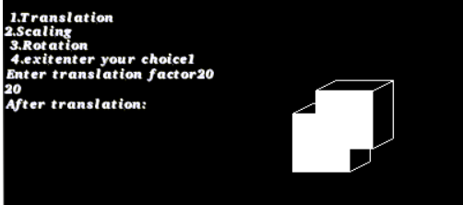

**SCALING:**

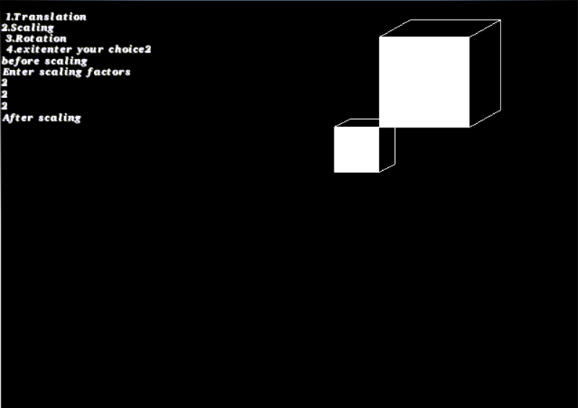

**ROTATION:**

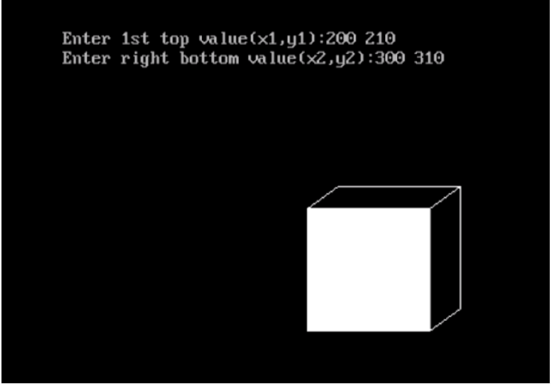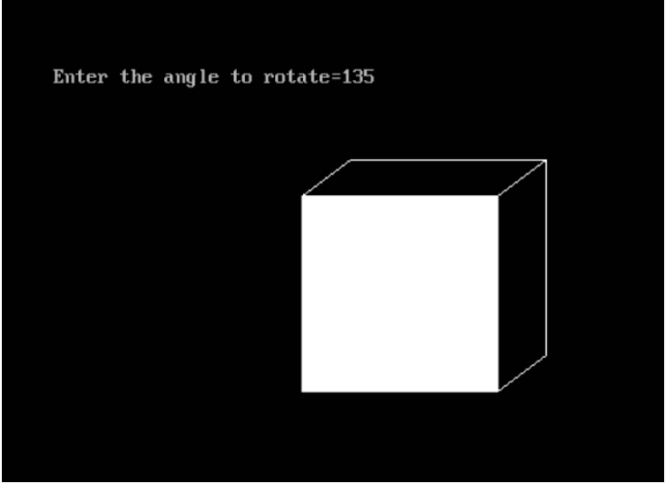

**REFLECTION:**

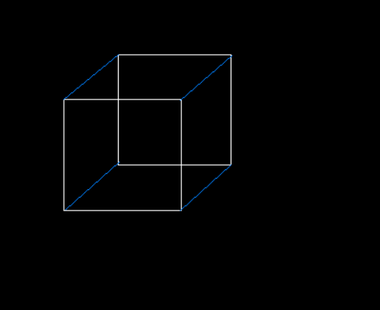

**SHEARING:**

